Git Exercises
(Submitted By : Akash yadav)

1- Initialize a Git Repository
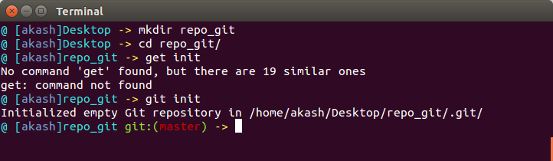
2- Add files to the repository
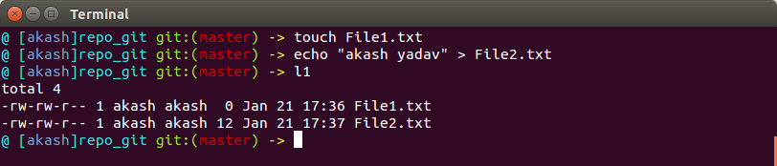
3- Unstage 1 file
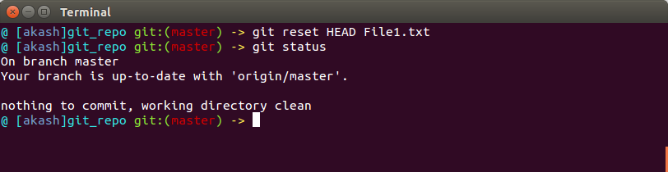
4- Commit the files
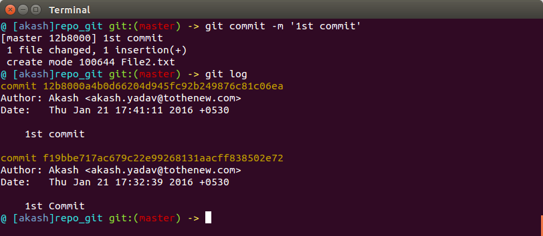
5- Add a remote
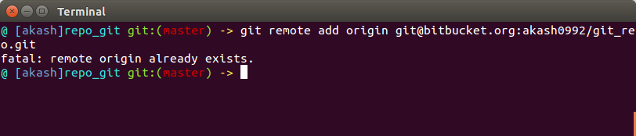
6- Undo changes to a particular file
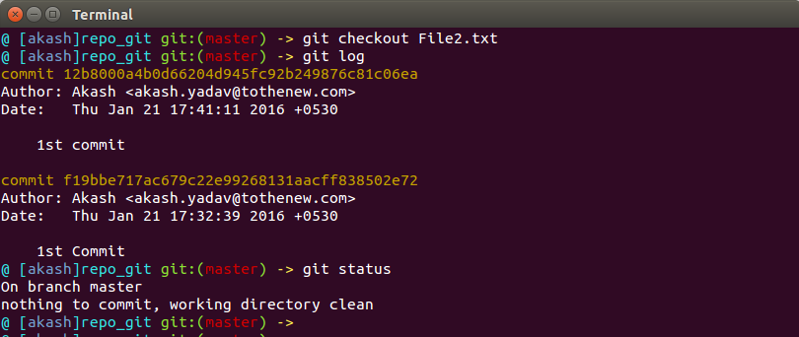
or
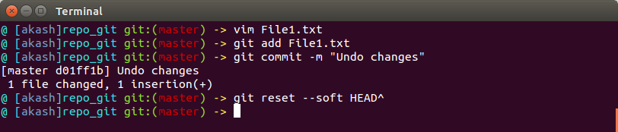

7- Push changes to Github
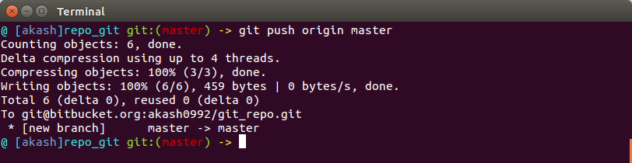
8- Clone the repository
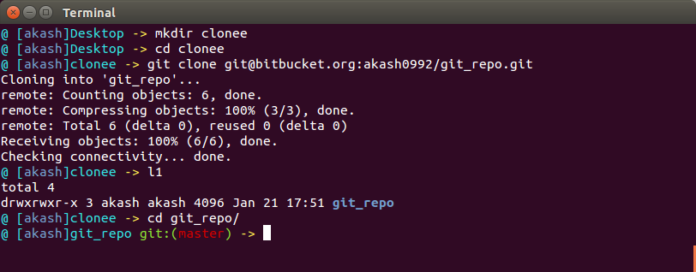
9- Add changes to one of the copies and pull the changes in the other.
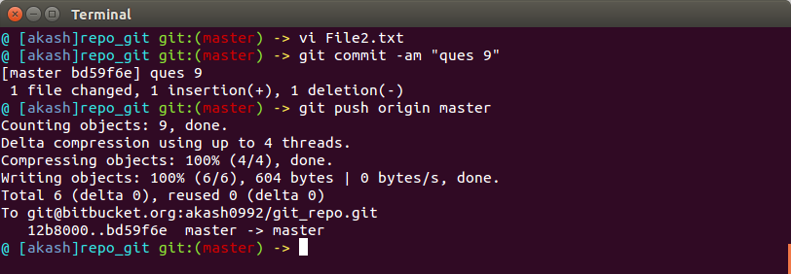
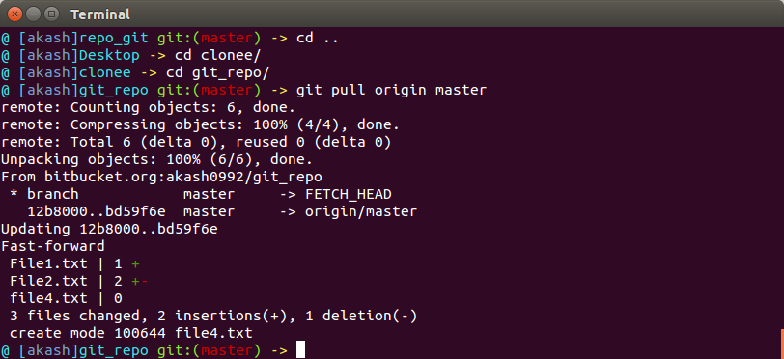
10- Add changes to both repos, try to push from both without taking a pull.

Changes in clone directory file:
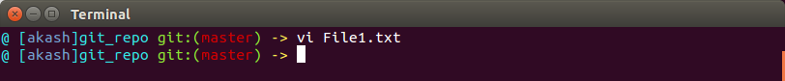
Changes in original directory file:
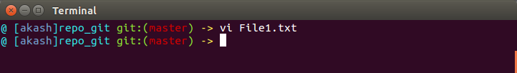
Push file of original directory :
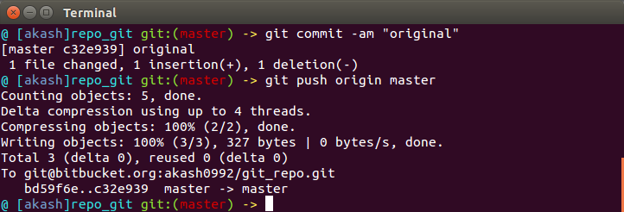

Push file of clone directory :
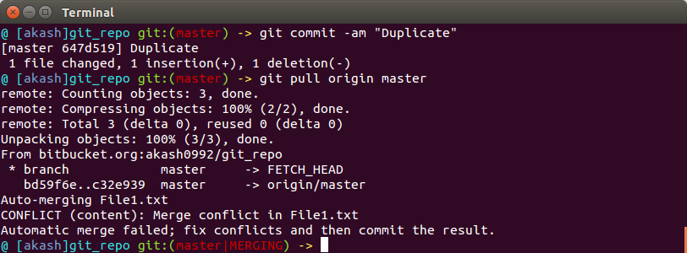
Error while pushing file from clone directory ( Reason : becouse clone git has old head pointer

To git@bitbucket.org:akash0992/git_repo.git
! [rejected] master -> master (fetch first)
error: failed to push some refs to 'git@bitbucket.org:akash0992/git_repo.git'
hint: Updates were rejected because the remote contains work that you do
hint: not have locally. This is usually caused by another repository pushing
hint: to the same ref. You may want to first integrate the remote changes
hint: (e.g., 'git pull ...') before pushing again.
hint: See the 'Note about fast-forwards' in 'git push --help' for details.

11- Check differences between a file and its staged version
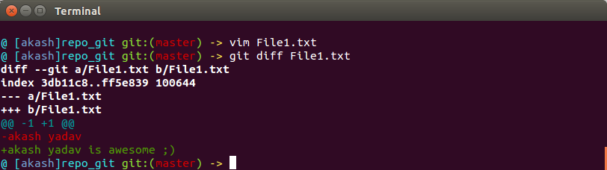
or
@ [akash]repo_git git:(master) -> git diff –staged

12- Ignore a few files to be checked in
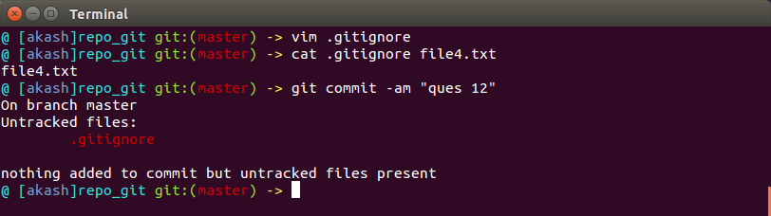
13- Create a new branch. Diverge them with commits
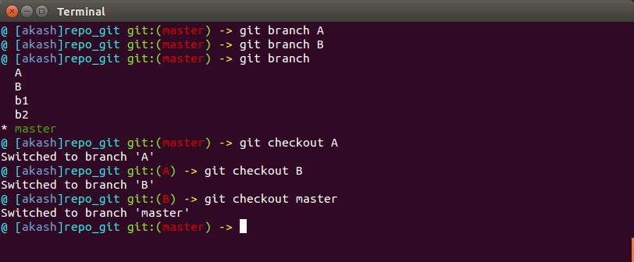
14- Edit the same file at the same line on both branches and commit
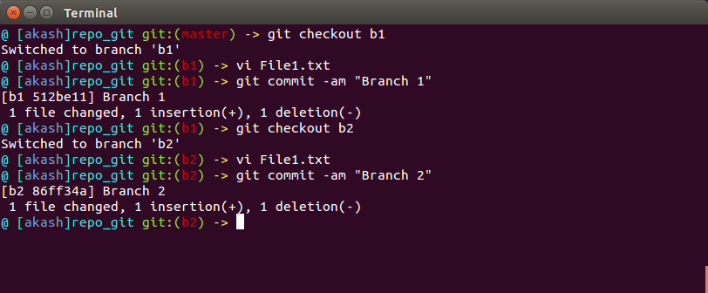
15- Try merging and resolve merge conflicts
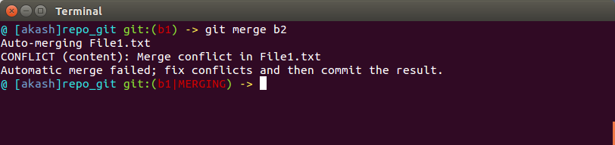
@ [akash]repo_git git:(b1|MERGING) -> vi File1.txt

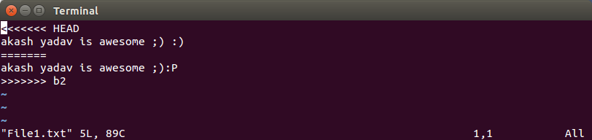
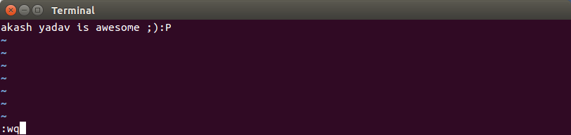
@ [akash]repo_git git:(b1|MERGING) -> git add File1.txt
@ [akash]repo_git git:(b1|MERGING) -> git commit -am "conflict resolved"
[b1 9bb737c] conflict resolved
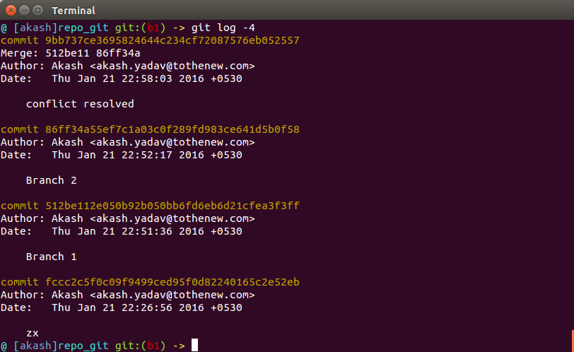

16- Stash the changes and pop them
